***Project 1 – Building A Simple iOS App***

By: Eric Dockery

Date: 5/13/2015

This project was designed to get students used to the Xcode environment buy designing a simple iOS application. This application adds two labels and two buttons to a single view application file. It teaches the students how to set property values and how to link them to objects on the main storyboard view controller with basic commands in Objective-C programming.

The logic employed and needed for the input and expected output for the project was to follow the guides of iOS Programming THE BIG NERD RANCH GUIDE as well as the video lectures presented by Dr. Imam on tegrity.

---------------------------------------------------------------------

SCREENSHOTS:

--------------------------------------------------------------------

LOADING SCREEN:

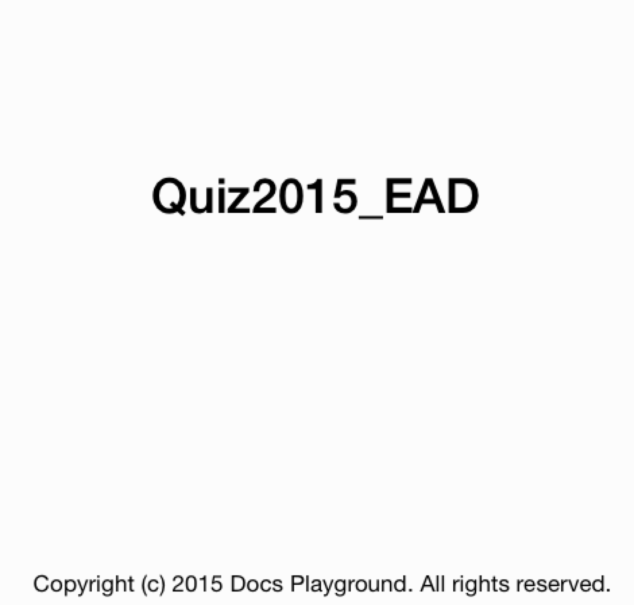

MAIN VIEW:

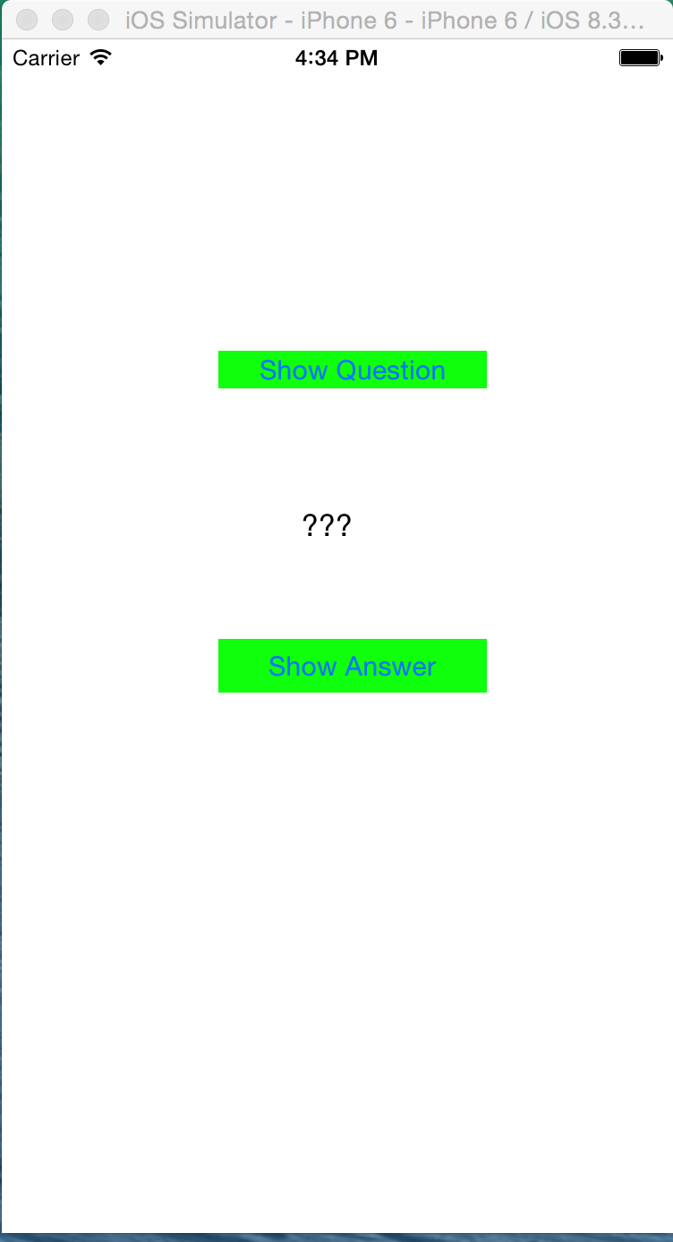

QUESTION 1: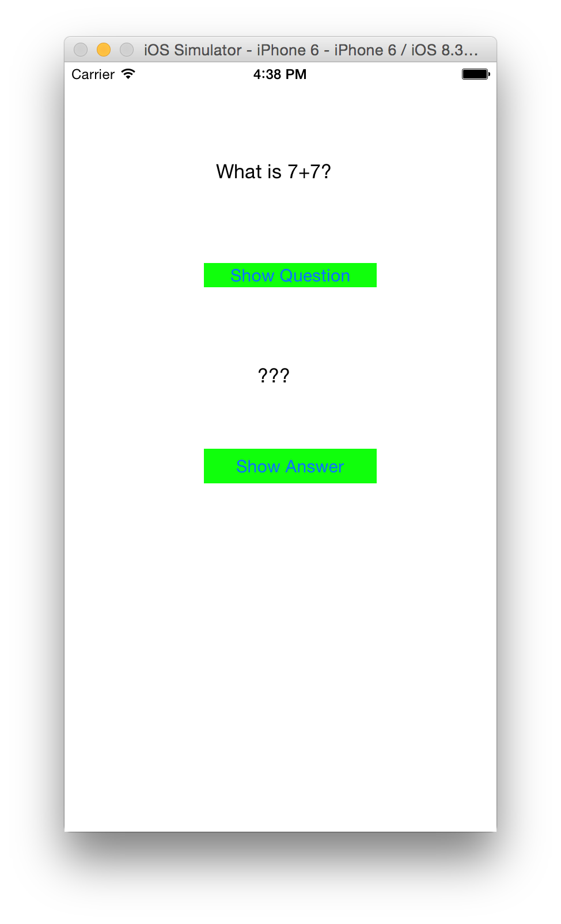

ANSWER 1: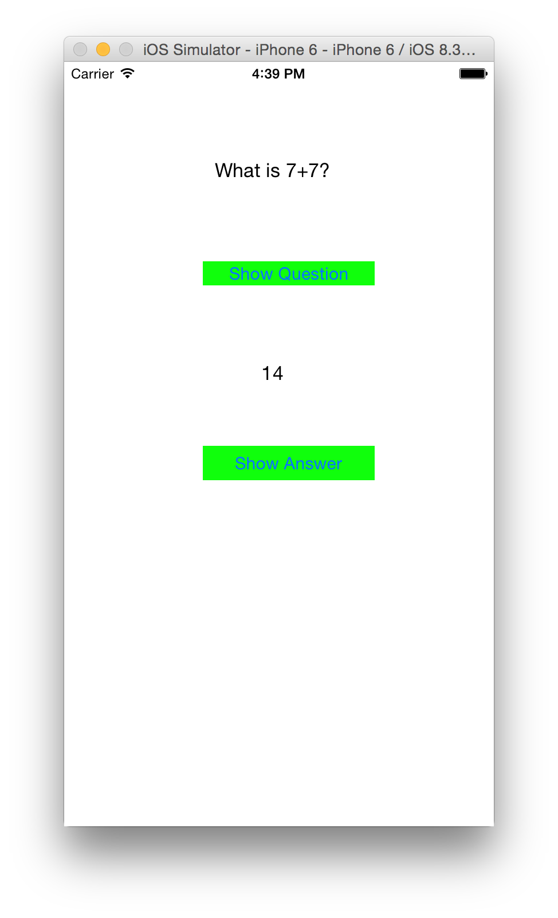

QUESTION 2: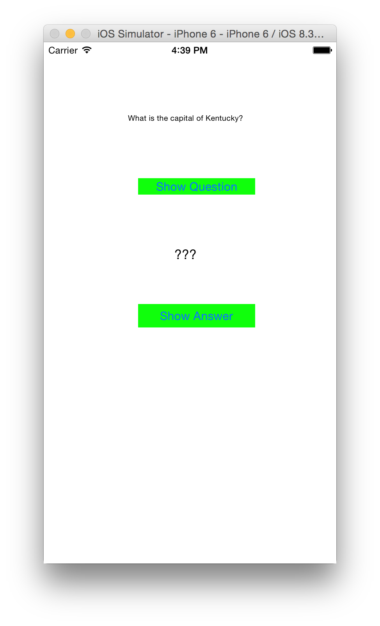

ANSWER 2: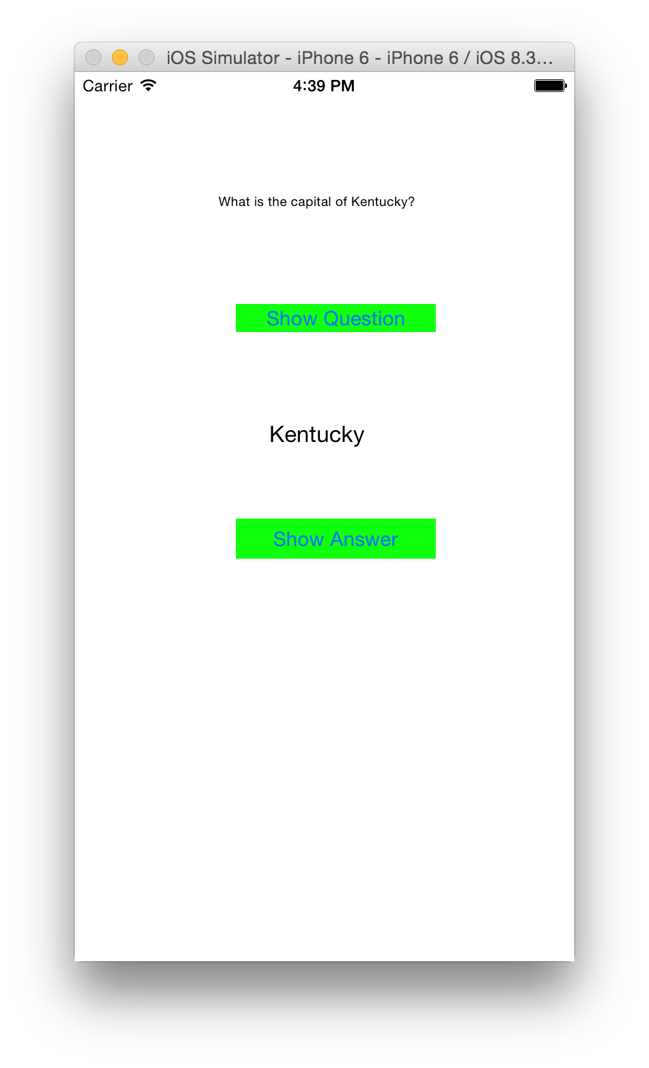

QUESTION 3: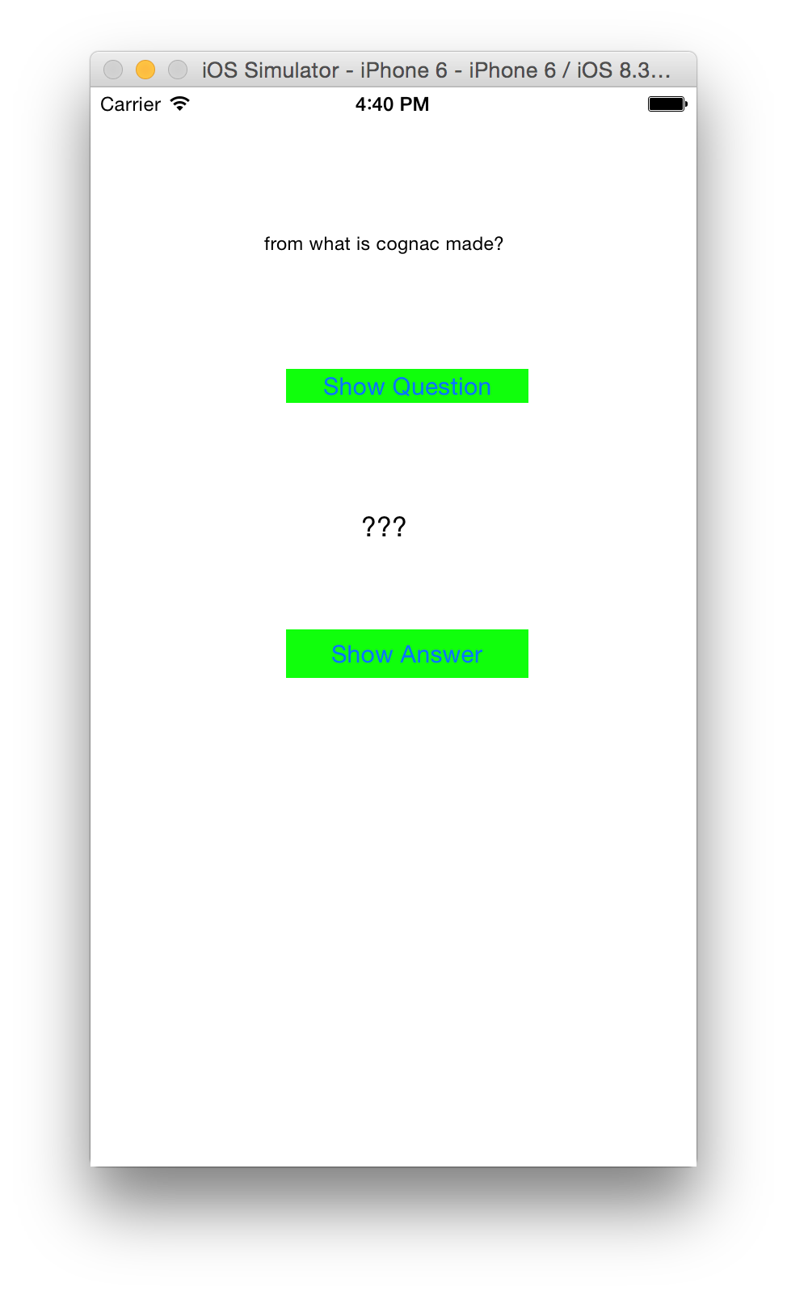

ANSWER 3: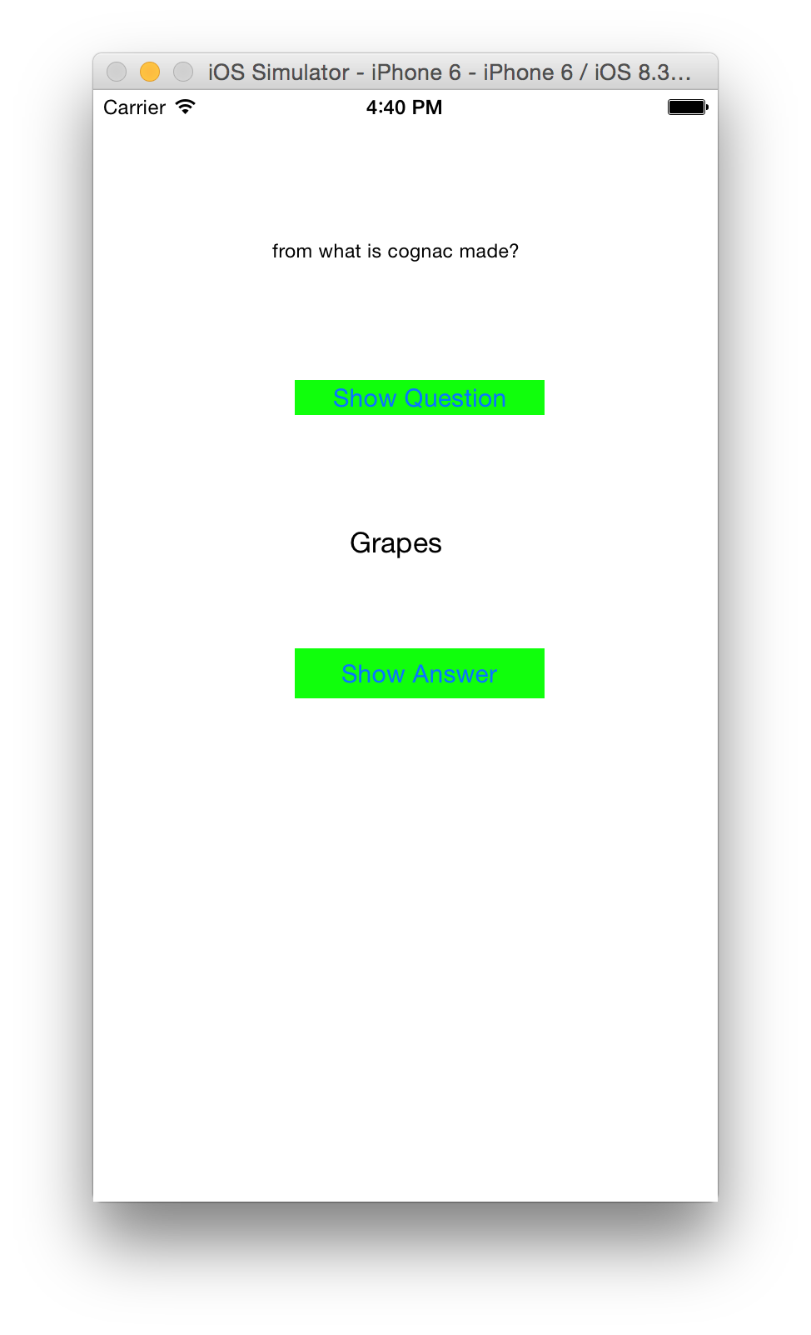

For the text on the second label I set a scaling font to make it more readable when implementing.